User’s Guide for USDA ARS Gateway and Node Wireless Data Logging Firmware with Acclima Inc. Hardware

Last Updated: July 25, 2022

# System Overview

The gateway and node wireless data logging system is a microcontroller-based system designed to work with SDI-12 sensors. These systems provide researchers a low-cost option for collecting environmental data from remote sites. Each system consists of a gateway, one or more nodes, and one or more sensors.

Figure 1. Gateway and Node System Components

Up to 16 uniquely addressed sensors are connected to a node. The node prompts the sensors to take measurements according to the time interval set by the user. Data from the individual sensors are compiled into timestamped data strings and saved to an onboard Flash chip. Nodes can be used as standalone data loggers without the use of a gateway. In such cases, users can print the data off the node using a serial terminal application such as the Arduino IDE Serial monitor or Termite.

When linked to a gateway, the node will send its compiled data to the gateway after each measurement interval via a Semtech LoRa (Long Range) radio. The gateway receives the data and store them to a microSD card. One gateway can accommodate up to eight nodes. With a Hologram SIM card installed and a 4G/LPWA cellular connection established, the gateway will send the data to Hologram’s cloud server. From there, data can be accessed via API.

# Hologram

The USDA-ARS gateway firmware uses Hologram to transfer data to the cloud. Hologram ([www.hologram.io](https://www.hologram.io/)) is a cellular platform for IoT devices and provides cellular subscriptions and access to a cloud server. Hologram SIM cards using roaming to connect to nearby towers regardless of network.

# Uploading Firmware Using Acclima’s Firmware Update App

Using the Firmware Update App is the easiest and fastest way to load firmware onto the nodes and gateways. Follow the procedure below to upload firmware to a device.

1. On a Windows PC, go to <https://github.com/ArduinoSoilH2O/GN-USDAARS-Acclima-3G>.
2. Click on the green “Code” button and select “Download ZIP”.

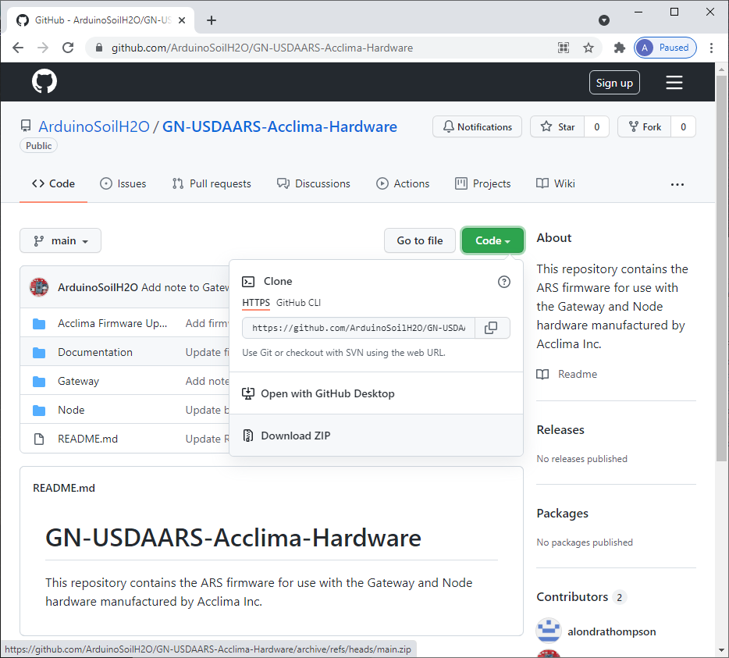

Figure 2. GitHub: Downloading repository as ZIP folder

1. Extract the contents of the zipped folder and open the folder.

Figure 3. Extract files from ZIP folder

1. Open the Acclima Firmware Update App folder. Ensure there are files named: Gateway_USDAARS_Acclima_Vxxxx.xx.xx.ino.hex and Node_USDAARS_Acclima_Vxxxx.xx.xx.ino.hex.

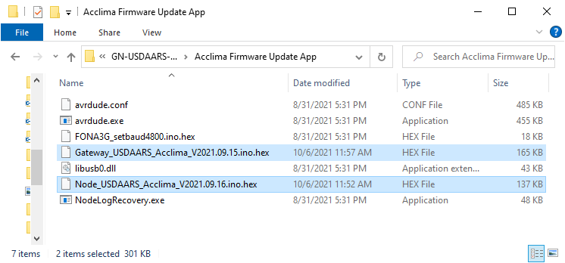

Figure 4. Firmware files highlighted in Acclima Firmware Update App folder

1. Double click on NodeLogRecovery.exe to open it. Connect the device and power on.
2. Click Options in the top tool bar and select the appropriate COM port.

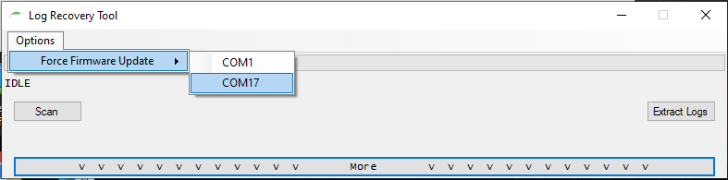

Figure 5. Firmware Update App: Select COM port

1. Select or navigate to the firmware file (ends in .ino.hex) you want to upload. Click Open.

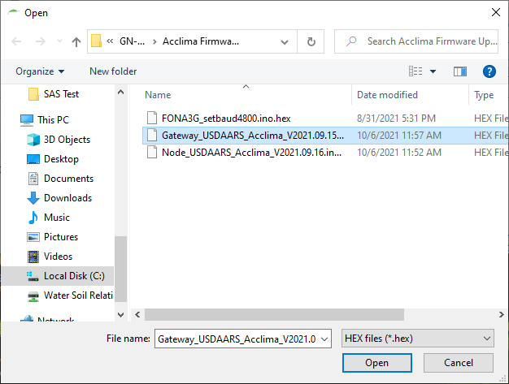

Figure 6. Firmware Update App: Select firmware file

1. Wait for the firmware to upload.

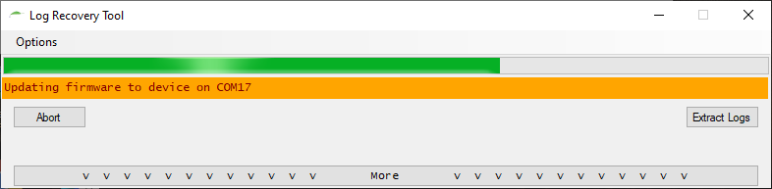

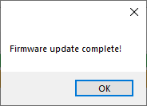

Figure 7. Firmware Update App: Uploading firmware

1. To select a different firmware file, click on the More button. Click the firmware file path and select another firmware file.

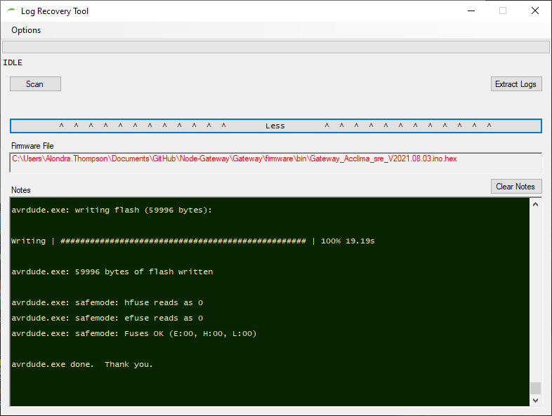

Figure 8. Firmware Update App: Select new firmware file

**Note**: The Extract Logs button does not work. This app only works to upload firmware, not extract data.

# Serial Terminal Communication

A serial application is required to enable communication between a PC, laptop, or tablet and the gateway/node hardware via a USB cable. Free applications available for download include the [Arduino IDE](https://www.arduino.cc/en/Main/Software_) and [Termite](https://www.compuphase.com/software_termite.htm). Images in this document were generated using the Arduino IDE.

## Settings

* Baud rate: 57600
* Input termination: No line ending (Arduino IDE)

## Arduino IDE Serial Monitor Setup

Figure 9. Arduino IDE: Select COM port

Figure 10. Arduino IDE: Set Serial Monitor settings

# Node Menu

## Menu Sections

The node menu has four sections: sensor scan results, metadata list, sensor menu, and configuration options.

### Sensor Scan

On startup, the node will scan the SDI-12 bus for active sensors and list the sensor IDs for each sensor found. Entering “S” will skip the scan and go directly to the menu.

Figure 11. Node menu: Sensor scan

### Metadata List

After the sensor scan results, the node will display a list of metadata.

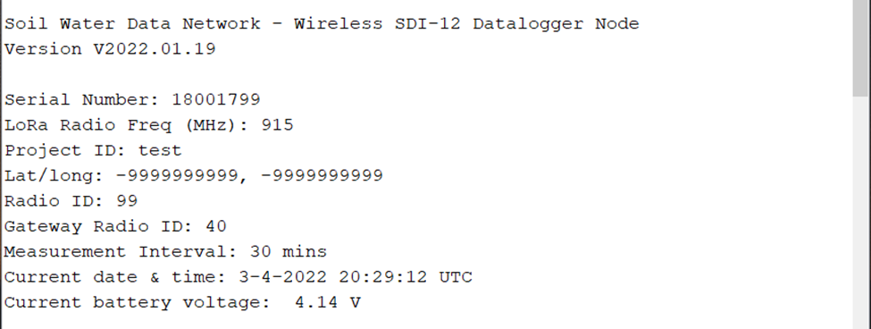

Figure 12. Node menu: Metadata list

The metadata are identified and defined in the following table.

Table 1. Node metadata

|  |  |  |  |
| --- | --- | --- | --- |
| **Format** | **Value** | **Description** | **Can be changed by user?** |
| V2022.01.19 | Firmware version | Push date of firmware revision | N |
| 18001799 | Serial number | Unique identifier for hardware, assigned by manufacturer | N |
| Test | Project ID | Project or site identifier. Up to 5 characters. | Y |
| 915 | LoRa radio frequency | Frequency band of LoRa radio transceiver in unit | N |
| 32.187060, 35.830295 (-999999999, -999999999 in figure) | Latitude, Longitude | Coordinates of installation location (will default to -999999999 if no value entered). Is hidden if include_latlong is not defined in the firmware code (line 115). | Y |
| 99 | Node radio ID | Radio transceiver identifier. Each radio within a network must have a unique radio ID between 0 and 99. Value defaults to the last two digits of the serial number. | Y |
| 40 | Gateway radio ID | Gateway radio transceiver ID. Is hidden if node is not to be used with a gateway. | Y |
| 30 mins | Measurement interval | Interval at which nodes will read sensors and send data to gateway. Options include 10-, 15-, 20-, 30-, or 60-minute intervals. | Y |
| 3-4-2022 20:29:12 UTC | Current time (UTC) | Date and time in MM-DD-YYYY HH:MM:SS UTC format. Time Zone cannot be changed. | Y |
| 4.14 V | Current battery voltage | In volts. Menu will display a warning if battery voltage below 3.4 V. | N |

### Sensor Menu

Options for interacting with the sensors are listed in the sensor menu.

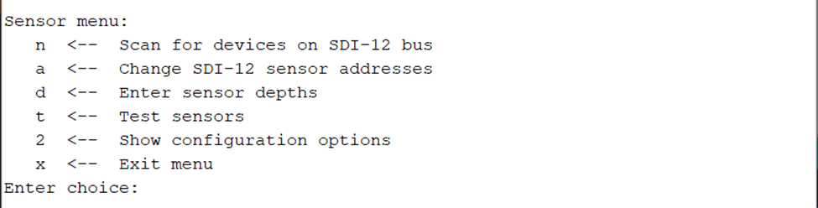

Figure 13. Node menu: Sensor menu

#### n – Scan for devices on SDI-12 bus

This option will initiate a scan of all possible SDI-12 addresses for active sensors. Sensor IDs of those found on the bus will print to the screen.

#### a – Change SDI-12 sensor addresses

This option allows users to change addresses of the sensors connected to the node. More than one sensor can be connected at a time.

#### d – Enter sensor depths

This option allows users to enter depths for each sensor found during the scan. Depths must be preceded by a “+” or “-“ and are limited to four character afterward (max +9999, min -9999). It is recommended that the depth should represent the midpoint of the sensed volume of the sensor as shown below. The node does not assign or ask for units, but users should take care to be consistent in how depth is determined and in what units.

Figure . Sensor measurement depth

#### t – Test sensors

This option will read the sensors and compile and print data strings three times.

#### 2 – Show configuration options

Entering “y” into the prompt this option brings up will expand the menu to show the configuration options beneath the user options. The gateway will continue to show the full menu until the user uses this same option to hide the configuration options.

### Configuration Options

The configuration options allow the user to edit the metadata, print or erase data, and turn debug statements on or off.

Figure 15. Node menu: Configuration options

#### 0 – Enter configuration string

Entering a single configuration string allows the user to set identifiers and other parameters without having to use each individual menu option. The configuration string is comma separated with values in the following order:

Project ID, serial number, node radio ID, gateway radio ID, measurement interval, number of sensors, sensor 1 SDI-12 address, sensor 1 depth, sensor 2 SDI-12 address, sensor 2 depth, …, sensor n SDI-12 address, sensor n depth, (latitude, longitude)

See “Sample Config String Generator.xlsx” to easily create configuration strings for a gateway and node set.

The string should not contain any spaces as in the following example:

FARM1,18000284,84,40,30,3,a,-10,b,-200,c,-1000,12.345678,-87.654321

This string sets the values as listed in Table 2.

Table 2. Node configuration string components

|  |  |
| --- | --- |
| **Value** | **Example** |
| Project ID | FARM1 |
| Serial number | 18000284 |
| Node radio ID | 84 |
| Gateway radio ID | 40 |
| Measurement interval | 30 |
| Number of sensors | 3 |
| Sensor 1 SDI-12 address | a |
| Sensor 1 depth | -10 |
| Sensor 2 SDI-12 address | b |
| Sensor 2 depth | -200 |
| Sensor 3 SDI-12 address | c |
| Sensor 3 depth | -1000 |
| Latitude | 32.187060 |
| Longitude | -35.830295 |

Entering “0” for the gateway radio ID will put the node in data logging only mode. Sensor depths must be preceded by a “+” or “-“ to indicative above or below surface and are limited to four characters after the sign (max +9999, min -9999). The configuration will fail if any of the values are missing or out of scope (ex. too many digits) or if the serial number does match what is stored in the device’s memory.

If include_latlng is not defined in the firmware code (line 114), latitude and longitude should not be included in the configuration string.

#### c – Set clock

The node will receive the current time from the gateway during the initial synchronization. Use this option if using the node as a standalone datalogger. The node will prompt the user for date and time values in UTC.

#### i – Enter project iD

This option allows the user to input a project or site identifier that will be included in the data string. The project ID is limited to a maximum length of five characters.

#### l - Enter or erase Lat/Long values

This menu option allows the user to enter latitude and longitude values (in decimal format). It is hidden when include_latlong is not defined in the firmware code (line 114).

#### g – Enter Gateway radio ID

This option will first ask if the user intends to use a gateway with the node. If so, the user will then enter the gateway radio ID. The ID must match what is saved on the gateway. If not, the node will set to datalogging only mode and return to the main menu.

#### r – Change Node radio ID

Users can choose to keep the default radio ID (the last two digits of the serial number) or enter a new one (values 0 through 99).

#### m – Set measurement interval

Users can set the measurement interval to 10, 15, 20, 30, or 60 minutes. The node reads the sensors and sends data to the gateway according to this interval.

#### p – Print data to screen

After the user selects this option, the node will ask if the user wants to print all the data or just the newest data to the screen. The newest data are those collected after the last time data were printed with this option. Printing all the data can take a few minutes depending on how much data are stored in the memory.

#### b – Turn debug statements on/off

This option allows the user to choose whether they want the gateway to print debug statements to the terminal windows as it runs. It is advisable to turn off the debug statements if the gateway is to run while not connected to a serial connection (in the field).

#### e – Erase all data

This option will erase everything in the data memory space.

#### 2 – Hide configuration options

Entering “y” into the prompt this option brings up will expand the menu to collapse the configuration options and show only the sensor menu.

# Gateway Menu

## Menu Sections

The gateway menu has three sections: metadata list, user options, configuration options.

### Metadata List

The top portion of the menu lists out metadata such as firmware version, identifiers, intervals, time, and battery voltage. It will also include alerts that Receiver Mode is on, debug statements are on, or that the battery voltage is low. The information will update after the values are changed.

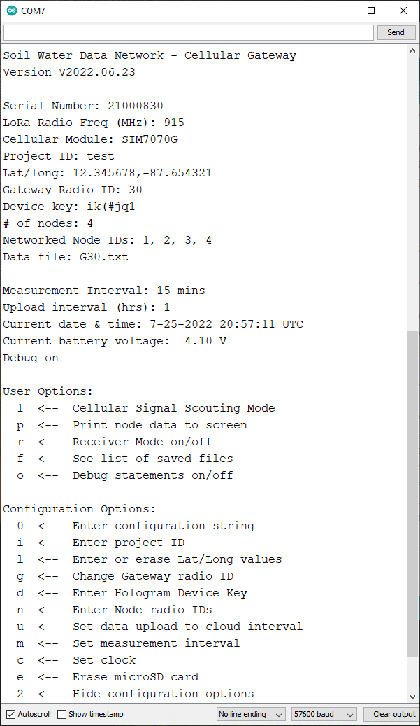

Figure 16. Gateway menu: Metadata

Table 3. Gateway metadata

|  |  |  |  |
| --- | --- | --- | --- |
| **Format** | **Value** | **Description** | **Can be changed by user?** |
| --- Receiver Only Mode --- (not shown) | Receiver Mode indicator | Indicates that gateway is in forced Receiver mode. Otherwise omitted. | Y |
| V2022.06.23 | Firmware version | Push date of firmware revision | N |
| 21000830 | Serial number | Unique identifier for hardware, assigned by manufacturer | N |
| 915 | LoRa radio frequency | Frequency band of LoRa radio transceiver in unit | N |
| SIM7070G | Cellular Module | Cellular module model (SIM7070G = LPWA; SIM5320A = 3G, America) | N |
| test | Project ID | Project or site identifier. Up to 5 characters. | Y |
| 12.345678, -87.654321 | Latitude, Longitude | Coordinates of installation location (will default to -999999999 if no value entered). | Y |
| 30 | Gateway radio ID | Two-digit transceiver identifier. Each radio within a network must have a unique radio ID between 0 and 99. Value defaults to the last two digits of the serial number. | Y |
| ik(#jq1 | Hologram device key | Eight-character device-specific identifier used to authenticate SIM when uploading data to Hologram server. Device keys are found on your Hologram Dashboard. Value is omitted if in Receiver mode. **Do not use a device key that includes a comma.** | Y |
| 4 | Number of nodes | Number of nodes to be networked with gateway (max. 8) | Y |
| 1, 2, 3, 4 | Node radio IDs | Unique radio identifiers of networked nodes. Values should be between 0 and 99. | Y |
| G30.txt | Data filename | Name of data text file on the microSD card. Defaults to Gxx, where xx is the radio ID of the gateway. | Y  (indirectly, by changing gateway radio ID) |
| 15 mins | Measurement interval | Interval at which nodes will send data to gateway. Options include 10-, 15-, 20-, 30-, or 60-minute intervals. | Y |
| 1 | Upload interval (hours) | Interval at which the gateway will upload data to the cloud or generate gateway data string (in Receiver mode). 1 or 4 hours. | Y |
| 7-25-2022 20:57:23 UTC | Current time (UTC) | Date and time in MM-DD-YYYY HH:MM:SS UTC format. Time Zone cannot be changed. | Y |
| 4.10 V | Current battery voltage | In volts. Menu will display a warning if battery voltage below 3.4 V. | N |
| Debug on | Debug status indicator | Indicates whether debug statements are on or off | Y |

### User Options

The user options execute specific functions that do not alter any configuration parameters that change the gateway’s performance.

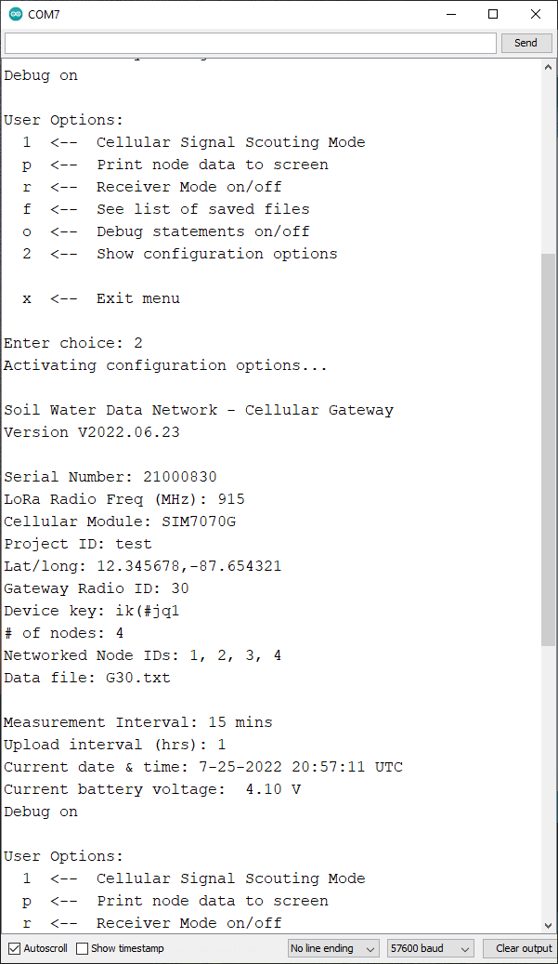

Figure 17. Gateway menu: User options

#### 1 - Cellular Signal Scouting Mode

The Cellular Signal Scouting Mode measures the current signal strength every second and gives a rating of EXCELLENT, GOOD, FAIR, or POOR according to the chart below.

|  |  |
| --- | --- |
| **RSSI Range (dBm)** | **Rating** |
| > -65 | EXCELLENT |
| -65 to -75 | GOOD |
| -75 to -85 | FAIR |
| -85 to -95 | POOR |
| -99 | UNKNOWN |

Scouting Mode requires a connection to the network to measure the signal strength. If the gateway cannot connect to the network, you will see the following error message in the terminal window:

ERROR: could not connect to network

If the gateway can connect to a network, Scouting Mode will print the RSSI and corresponding rating.

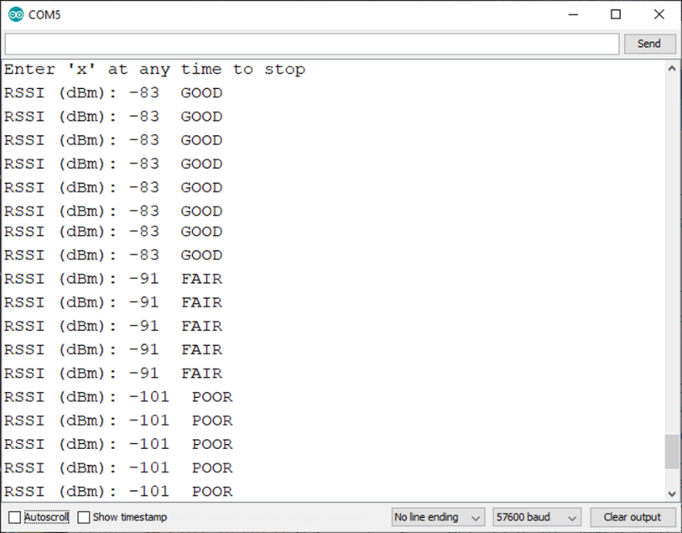

Figure 19. Cellular Scouting Mode output (from 3G Gateway)

#### p – Print node data to screen

This option prints everything saved in the data file to the terminal window for the user to view. It does not download the data to the device, as in create a file on the device. It simply prints the data to the window terminal. The user can then copy and paste the data from the window into another file if desired.

#### r – Receiver Mode on/off

Users can activate or deactivate Receiver mode during which the gateway does not upload data to the cloud. It will also ask at which interval the user would like the gateway to compile its data string (every 1 or 4 hours).

Entering a zero for the device key in the configuration string will also put the gateway into Receiver Mode. In this mode, the gateway will not upload data to the cloud. With a SIM card, the gateway will continue to update its clock daily from the NIST server. Otherwise, the gateway will skip all cellular functions.

#### f – See list of saved files

This option prints a list of the names and sizes of all files saved on the microSD card to the terminal window.

#### o – Debug statements on/off

This option allows the user to choose whether they want the gateway to print debug statements to the terminal windows as it runs. It is advisable to turn off the debug statements if the gateway is to run while not connected to a serial connection (in the field).

#### 2 – Show configuration options

Entering “y” into the prompt this option brings up will expand the menu to show the configuration options beneath the user options. The gateway will continue to show the full menu until the user uses this same option to hide the configuration options.

### Configuration Options

These options allow the user to set identifiers, intervals, and Receiver Mode independently or all at once with the configuration string.

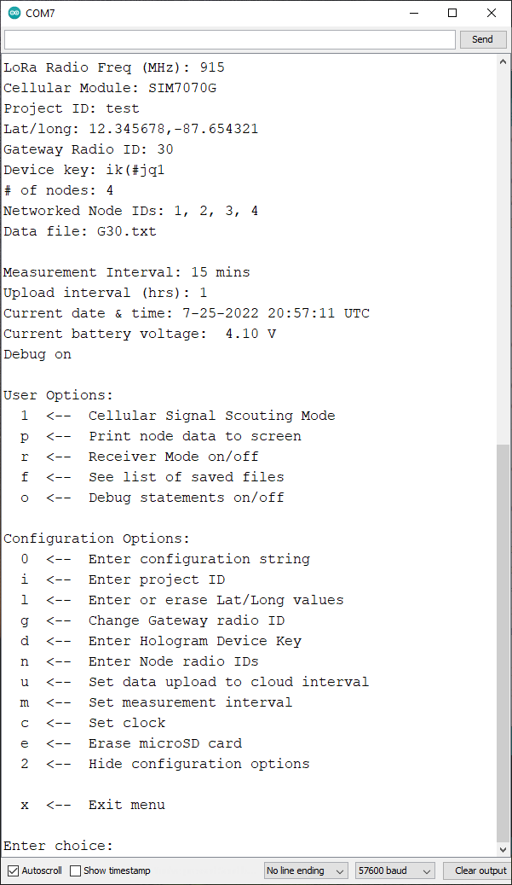

#### 0 – Enter configuration string

Entering a single configuration string allows the user to set identifiers and other parameters without having to use each individual menu option. The configuration string is comma separated with values in the following order:

Project ID, serial number, device key, gateway radio ID, number of nodes, node 1 radio ID, node 2 radio ID, …, node n radio ID, measurement interval, upload interval, latitude, longitude

See “Sample Config String Generator.xlsx” to easily create configuration strings for a gateway and node set.

The string should not contain any spaces as in the following example:

FARM1,21000140,ik(#jq1>,40,4,84,93,89,20,10,1,32.187060,-35.830295

This string sets the values as listed in Table 4.

Table 4. Gateway configuration string components

|  |  |
| --- | --- |
| **Value** | **Example** |
| Project ID | FARM1 |
| Serial number | 21000140 |
| Device key* | ik(#jq1> |
| Gateway radio ID | 40 |
| Number of nodes | 4 |
| Node 1 radio ID | 84 |
| Node 2 radio ID | 93 |
| Node 3 radio ID | 89 |
| Node 4 radio ID | 20 |
| Measurement interval (mins) | 10 |
| Upload interval (hrs) | 1 |
| Latitude (deg) | 32.187060 |
| Longitude (deg) | -35.830295 |

\***Note**: the comma-separated configuration string is why you should not use a device key that includes a comma. Doing so will cause the configuration to fail.

Entering “0” for the device key will put the gateway into Receiver Mode. The configuration will fail if any of the values are missing or out of scope (ex. too many digits) or if the serial number does match what is stored in the device’s memory.

If include_latlng is not defined in the firmware code (line 115), latitude and longitude should not be included in the configuration string.

#### i – Enter project ID

This option allows the user to input a project or site identifier that will be included in the data string. The project ID is limited to a maximum length of five characters.

#### l – Enter or erase Lat/Long values

This menu option allows the user to enter latitude and longitude values (in decimal format). It is hidden when include_latlong is not defined in the firmware code (line 115).

#### g – Change Gateway radio ID

This option will ask the user if they want to change the radio ID from the default value (the last two digits of the serial number). If so, the user can enter a radio ID value between 0 and 99.

#### d – Enter Hologram Device Key

This option allows users to enter the device key associated with the gateway’s Hologram SIM card. The menu option is hidden when the gateway is in Receiver mode.

#### n – Enter Node radios IDs

This option will first ask how many nodes are at the site i.e., how many nodes are to be networked to the gateway. It will then iteratively ask for the radio IDs for each node. The number of nodes per gateway is capped at eight.

#### u – Set data upload to cloud interval

This option is reworded to “Set gateway data interval” when the gateway is in Receiver mode. The user can choose either an hourly interval or every four hours.

#### m – Set measurement interval

Users can set the measurement interval to 10, 15, 20, 30, or 60 minutes. The gateway retrieves data from the nodes according to this interval.

#### c – Set clock

This option will first attempt to get the current time from the NIST time server. If it succeeds the gateway will return to the menu. If it fails, the gateway will prompt the user to enter the time manually in UTC.

#### e – Erase microSD card

This option will delete all files saved on the microSD card.

#### 2 – Hide configuration options

Entering “y” into the prompt this option brings up will expand the menu to collapse the configuration options and show only the user menu.

# Field Installation

## Gateway

Placement of the gateway in the field is of utmost importance to its successful operation. The gateway controls two things:

1. Compiling data from all nodes. For the nodes to send data to the gateway by LoRa (Long Range) radio transmission, they must be within “line-of-sight”, meaning you should be able to see one from the other either with the naked eye or binoculars. Obstructions like hills or buildings will block the radio transmissions, but plant structures like corn will not interfere much.
2. The data transfer to the cloud for real time data collection. The gateway needs good cellular reception to send data and receive accurate time data from the NIST server.

The gateway and node system relies on cellular connectivity for real-time data access and management. The system has built-in data backup redundancy in case of connectivity issues. Taking time to locate cellular reception and identify the best location for the gateway enables remote system monitoring and will save time in the long run.

### Locating the Gateway

Use the Signal Scouting mode to choose a location for the gateway. Scout the field and surrounding area for possible locations to install the gateway. Ideal conditions are:

* Highest signal rating achievable in scouted area
* Within line-of-sight of the nodes (you can see the nodes with your naked eye or with binoculars)
* At a higher elevation than the test plots (on top of a hill if possible)
* Accessible
* In full sun

To select a location for installing the gateway:

1. Identify 3 to 5 locations that satisfy the criteria above.

**→ Tip**: Flagging prospective locations will help you keep track of them.

1. Connect the gateway to the tablet.
2. Select and stand at the first prospective location for the gateway.
3. Open a serial terminal app.
4. Select menu option “1” to enter the Signal Scouting mode.
   1. If the rating is EXCELLENT, enter “x” into the input bar to exit Scouting Mode and turn off the gateway. Disconnect the gateway from the tablet. Install the gateway but do not turn it back on until after you have installed the nodes.
   2. If the gateway successfully connects to the network, note the signal strength rating at that location. Move on to Step 6.

**→ Tip**: Write the rating on the flag with a permanent marker.

* 1. If the gateway does not connect to the network, enter “x” into the input bar to exit Scouting mode. Do not turn off the gateway. Move on to Step 6.

1. Proceed to the next location you marked and repeat step 5 until you find the location with the highest signal strength rating.
   1. If the gateway fails to connect to the network at all locations, choose the most convenient location and install the gateway there. Plan to manually download data every two weeks after installation (see Manual Data Collection).

To install the gateway, you will need a 1-1/2” flight auger to dig a hole deep enough to stabilize the above-ground portion of the pipe. Insert the 1-1/4” PVC pipe into the hole but do not mount the gateway on top. Ensure the conduit opening in the enclosure is plugged with duct seal and that there are desiccant packets and a humidity indicator inside. Take the gateway with you as you install the sensors and nodes.

## Node

The node is compatible with SDI-12 sensors that use address-based communication with the data logger. This means that sensors can be connected into a junction and one cable connecting the junction to the node. The node can accommodate up to 16 sensors at once.

1. Install and connect your sensors either directly to the node or to a junction that connects to the node. We recommend plugging the conduit on the node enclosure with duct seal after pulling the sensor cables through to limit moisture entering the box. Putting desiccant packs and humidity indicator in the box will also help protect the circuitry from moisture.
2. Dig out a hole for the mounting pipe using a 1-1/2” flight auger and insert the pipe. Mount the node on the pipe. Install all sensors and nodes before turning the nodes on.
3. Once the sensors and mounts are installed, turn the nodes on.
4. Turn on the gateway while you are still near the nodes.
   1. **If you were unable to find a cellular network connection with the gateway,** connect the gateway to a laptop or tablet and open a serial terminal application (see Serial Terminal Communication). Use menu option “c” to enter the time in UTC. Enter “x” into the input bar to exit out of the menu. Disconnect the USB cable. Do not restart the Gateway.

## Initialization

The status LED on the nodes and gateway should be lit during the initial synchronization. The LED on the nodes will turn off after they have successfully sent a test measurement to the gateway. The gateway LED will turn off after it sends the received test data to the cloud, or after two hours. If the LEDs stay on for longer than 20 minutes, it is likely that the synchronization failed. If this happens, connect a laptop or tablet to the gateway and open a serial terminal app. Restart the nodes and gateway and watch the gateway output for any obvious errors.

# Manual Data Collection

The gateway saves data received from the nodes to a microSD card. It creates a data file and a dump file. The data filename is formatted “G--.txt”, where the blanks are filled with the radio ID. The dump file is name “DUMP.txt”. The dump file gets deleted and regenerated upon each successful upload to the cloud. The data file holds all the data. In Receiver Mode both files will be the same.

Each node also saves its own data to an onboard Flash chip. Users can print the data to a serial terminal window using the node’s menu and can then copy and paste the data into a file. The node will erase the oldest data to make room for new data if the memory chip is full therefore users should make sure to print the data regularly if this is the primary method of data retrieval.

# Data String Formats

Raw data strings are delimited with a ~.

## Gateway

The gateway will generate a data string every upload interval (every 1 or 4 hours).

V2021.09.09~test~32.187060,35.830295~21000140~4.18~25.25~0~0.13~2021-9-15_18:03:01_UTC~-79

Table . Components of gateway data string

|  |  |
| --- | --- |
| **Example** | **Value** |
| V2021.09.09 | Firmware version |
| test | Project ID |
| 32.187060,35.830295 | Latitude, Longitude (omitted if include_latlng not defined in code) |
| 21000140 | Serial number |
| 4.18 | Battery voltage (V) |
| 25.25 | Enclosure temperature (°C) |
| 0 | Photovoltaic current (mA) |
| 0.13 | Photovoltaic voltage (V) |
| 2021-9-15_18:03:01_UTC | Timestamp |
| -79 | Cellular Received Signal Strength Indicator (RSSI, dBm, omitted if in Receiver mode) |

## Node

The nodes will read sensors and compile the outputs into one string per measurement interval.

V2021.08.31~test~-9999999999,-9999999999~18000120~3.99~24.00~2520~2.52~2021-9-15_18:30:00_UTC~s14Acclima TR310H2.214006302~-10~0.0~22.8~1.2~0~735~t14Acclima TR310H2.214006275~-100~0.0~22.8~1.2~0~720~-67

Table . Components of node data string

|  |  |
| --- | --- |
| **Example** | **Value** |
| V2021.08.31 | Firmware version |
| test | Project ID |
| -9999999999,-9999999999 | Latitude, Longitude |
| 18000120 | Serial number |
| 3.99 | Battery voltage (V) |
| 24.00 | Enclosure temperature (°C) |
| 2520 | Photovoltaic current (mA) |
| 2.52 | Photovoltaic voltage (V) |
| 2021-9-15_18:30:00_UTC | Timestamp |
| s14Acclima TR310H2.214006302 | Sensor ID |
| -10 | Sensor depth (“-“ indicates below ground) |
| 0.0~22.8~1.2~0~735 | Output from Acclima TDR310H sensor (VWC, T, K, EC, Tt)* |
| -67 | LoRa Received Signal Strength Indicator (RSSI, dBm, added by gateway upon receipt of string) |

*With Acclima TDR sensors, the node firmware will substitute the pore water EC value with the signal travel time. Volumetric Water Content is also converted from % to m3/m3.

Figure 20. LoRa Received Signal Strength Indicator scale

# Accessing Data from Cloud

## Viewing Data on Hologram

Log in to your Hologram Dashboard, [dashboard.hologram.io](https://dashboard.hologram.io/account/login?message=expired&redirectto=%2Forg%2F12018%2F). Click on the console icon near the bottom of the window. This will expand a lower window showing the most recent data received from any of your devices.

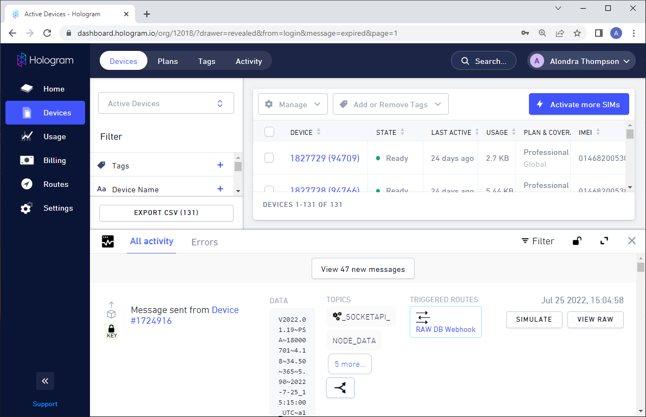

Click on the button at the top of the window to view any new messages.

To view data from a specific device, click on the device number from the list first and then click on the console icon as shown below.

## Downloading Data from Hologram

The Hologram console is a helpful way to view the most recent data but does not work well for scraping that data. Data stored on Hologram are available for extraction using an API key specific to your account. You can develop your own scraping method to pull data into an existing database or other format.

Your API key and Organization ID can be found on the Hologram Dashboard by clicking on “Settings” and selecting what you’re looking for at the top of the window.

### PyHOLA

If you do not have the experience available to develop your own method, the Water and Irrigation Management Lab at the University of Nevada Reno created a Python-based executable program called PyHOLA that downloads data into a text file. The executable is available for download at <https://sourceforge.net/projects/pyhola/files/>.

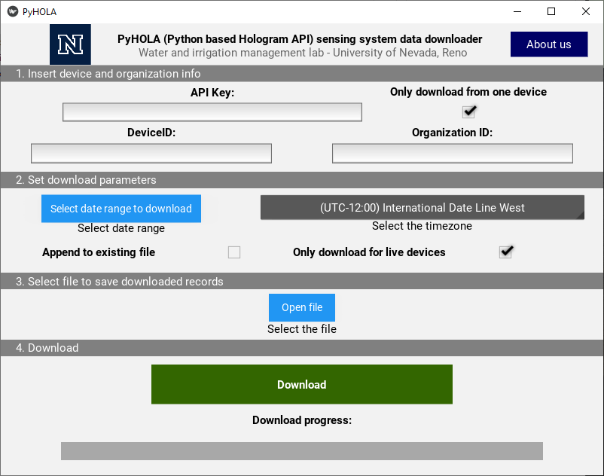

This program allows the user to download data from one or more devices over a specified date range. Further instructions are available on the download page.

The images below demonstrate the process of downloading data using PyHOLA.

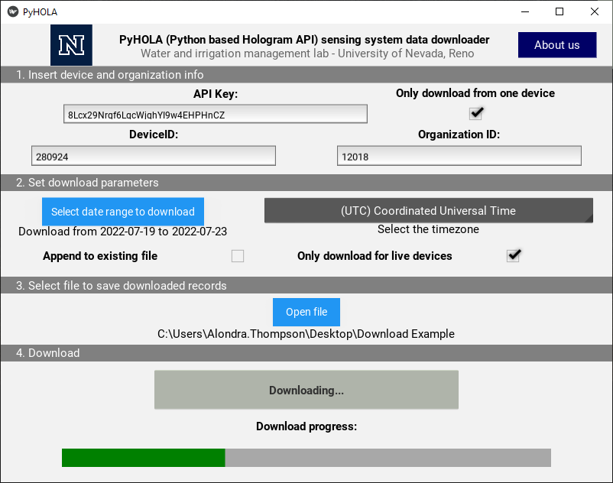

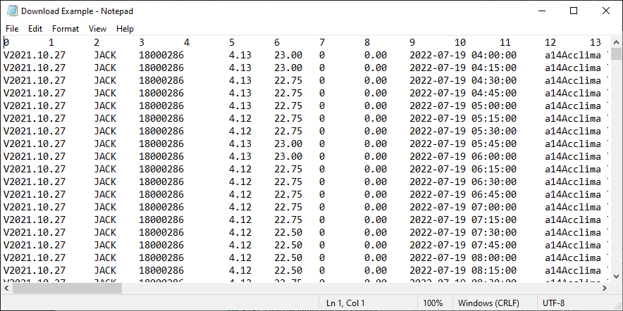

# Troubleshooting Common Issues